| **Test Name** | | Resolution of charge a room for service after the guest has checked out bug. | | | |
| --- | --- | --- | --- | --- | --- |
| **Use Case Tested:** | | Check out Service | | | |
| **Test Description:** | | This test script tests the resolution of bug in the Check Out use case of Hotel Management System. This test is performed to check whether reported bug of possible to charge a room for service after the guest has checked out is solved. | | | |
| **Pre-conditions** | | The Hotel Management System application must be running, and the user must proceed book room, check in, record service and check out before trying to charge the room. | | | |
| **Post-conditions** | | Service cannot be added to checked out room. | | | |
| **Notes:** | | As described in Pre-condition, user must follow book room, check in, record service and check out before trying to charge a room for service after the guest has checked out. So, test data table will show all the values that was provided during the test. | | | |
| **Result (Pass/Fail/Warning/Incomplete)** | | Pass, the bug is no longer exist during test. | | | |
|  | **TEST STEP** | | **EXPECTED TEST RESULTS** | P | F |
|  | User choose Book a Room from menu and create a booking. | | Room is booked for user with information in test table. | P |  |
|  | User choose Check in a Room from menu and check in. | | User was able to check in to the room. | P |  |
|  | User choose Register service and add Restaurant and Room Service of 300 and 200 cost respectively. | | Charges were shown to be added with visual text. | P |  |
|  | User choose Check out and continue to pay service charge and check out. | | All the cost incur during the stay was presented and user was able to check out successfully. | P |  |
|  | User choose record service | | User should not be able to add service charge to checked out room. | P |  |
| 5.1 | User choose record service | | Prompt to enter room number. | P |  |
| 5.2 | User enter checked out room number. | | Prompt user to re-enter room number again, no booking found. | P |  |

|  |  |  |  |  |
| --- | --- | --- | --- | --- |
|  | **Test Data Table** | | | |
|  |  | **1** | **2** | **3** |
| 1. Book Room | Main Menu | B | B | B |
| Enter phone number | 123 | 321 | 111 |
| Enter guest name | Bikram | Romeo | Chitra |
| Enter guest address | 12 Home | 12 Hotel | 21 Home |
| Enter room type selection | D | S | D |
| Enter number of occupants | 2 | 1 | 2 |
| Arrival Day: Enter day(dd) | 11 | 11 | 11 |
| Enter month (mm) | 10 | 10 | 10 |
| Enter year () | 2018 | 2018 | 2018 |
| Enter length of stay | 2 | 1 | 2 |
| Enter credit card type selection | M | V | V |
| Enter credit card number | 1 | 2 | 1 |
| Enter CCV | 1 | 2 | 1 |
| Hit <enter> to continue | ENTER< | ENTER< | ENTER< |
| 1. Check in | Main Menu | C | C | C |
| Enter confirmation number | 1192018201 | 1192018101 | 1192018201 |
| Confirm check-n? (Y/N) | Y | Y | Y |
| Hit <enter> to continue | ENTER< | ENTER< | ENTER< |
| 1. Record Service | Main Menu | R | R | R |
| Enter Room Id | 201 | 101 | 201 |
| Enter service type | R | B | R |
| Enter cost | 300 | 200 | 200 |
| Hit <enter> to continue | ENTER< | ENTER< | ENTER< |
| 1. Check out | Main Menu | D | D | D |
| Enter room number | 201 | 101 | 201 |
| Accept charges(Y/N) | Y | Y | Y |
| Enter credit card type selection | M | V | V |
| Enter credit card number | 1 | 1 | 1 |
| Enter CCV | 1 | 1 | 1 |
| Hit <enter> to continue | ENTER< | ENTER< | ENTER< |
| 1. Record Service | Main Menu | R | R | R |
| Enter Room Id | 201 | 101 | 201 |

# Screenshot of Bugs being resolved.

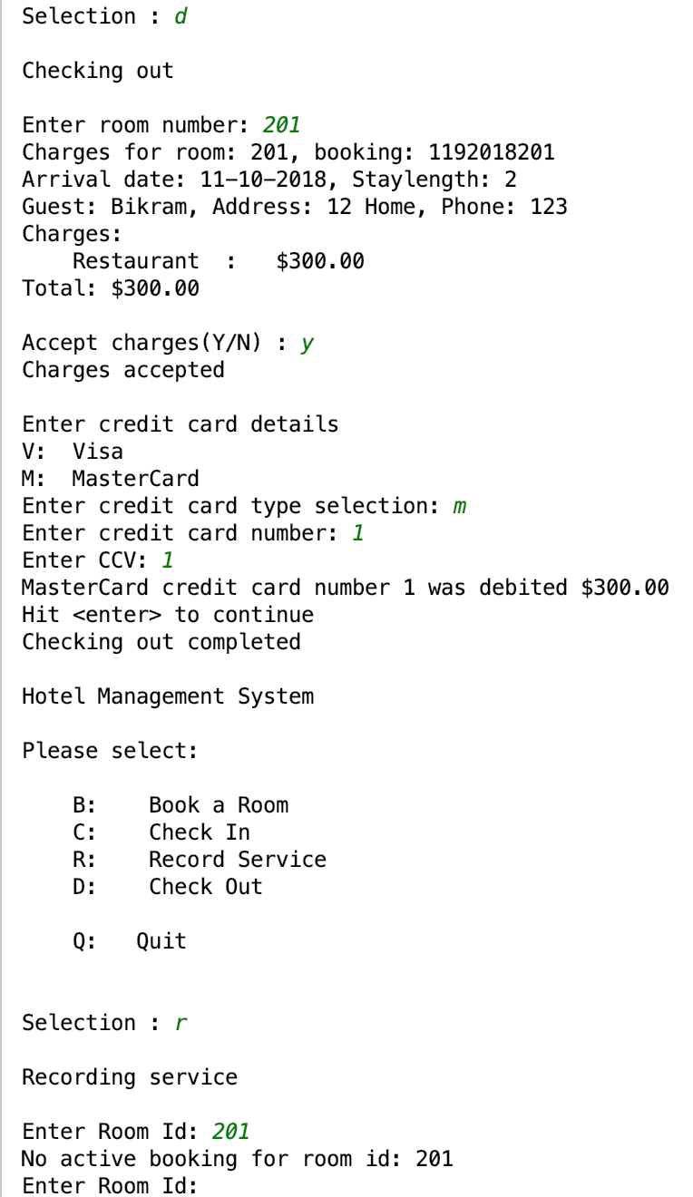

Figure: Test data 1 output showing bug has been resolved.

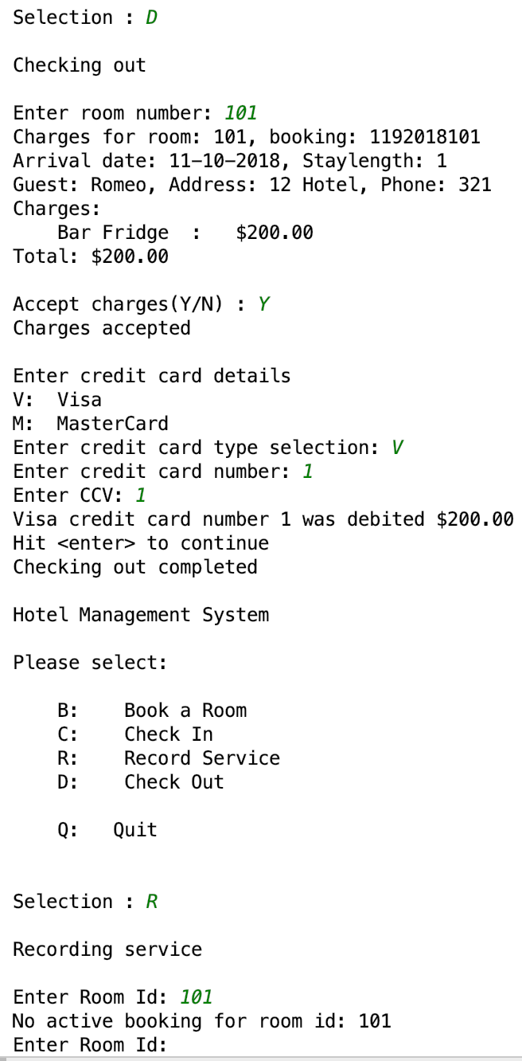

Figure: Test data 2 output showing bug has been resolved.

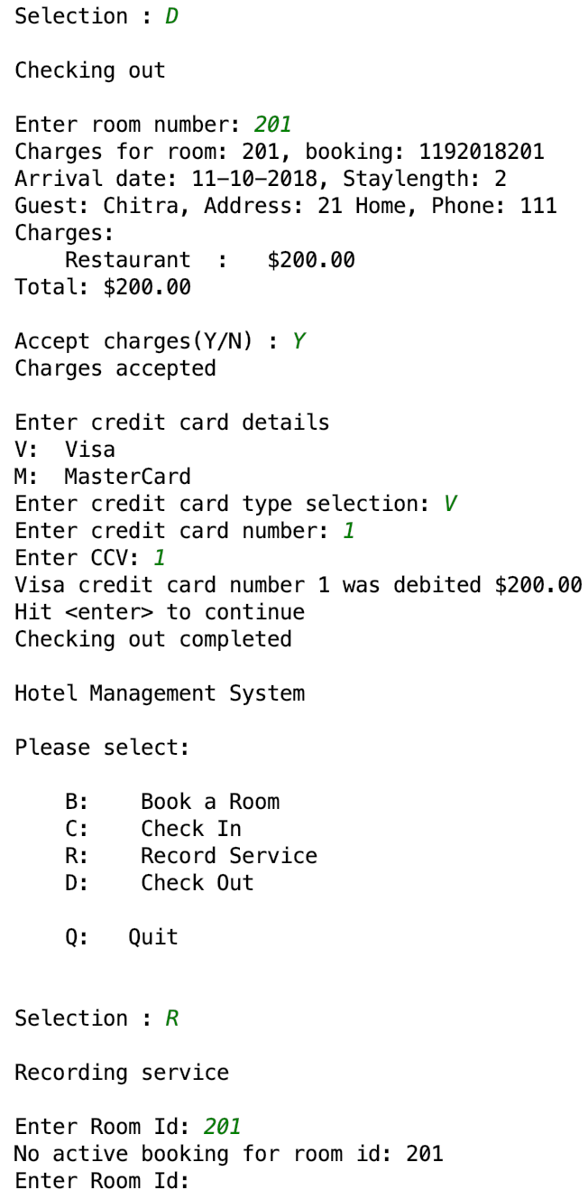

Figure: Test data 3 output showing bug no longer exists.